Checklist for the
TxEIS BANK RECONCILIATION
_______1. Before Starting
- Post bank fees, bank charges and bank drafts as “District Written Checks”.
- Post deposits as “Cash Receipts”, including interest deposits and electronic transfers into the account.
- Post returned checks as a negative cash receipt. (They will be on the cash receipt journal for easy verification.)
- Keep list of any JV’s posted to “cash accounts” for verification with the bank statement.

_______2. Items Needed to begin Bank Reconciliation:
- Bank Statements – Make a copy to work with.
- Prior month reconciliation report.
  - Reconciliation report with identified adjustments
  - Prior month list of Outstanding Deposits.
  - Prior month list of Outstanding Checks.
- Cash Receipt Journal (FIN1000) for the current accounting period by “Bank Acct”
- Check Register (FIN1250) for the current accounting period by “Bank Acct”
- Expenditure and Liquidation Journal (FIN1050)
- Check Payment List (FIN1300) for the current account period (print fund totals also)
- General Ledger Account Summary – for Cash Accounts.

_______3. Create Transactions
Extract transactions from the Finance and Human Resources

Bank Reconciliation > Maintenance > Bank Transactions >
Create Transactions

a. Under the Bank Account Grp: select the bank account group code to be used by clicking the ellipses button.
- Enter the GL File ID
- Accounting period: Type the accounting period to be used. The leading zero is not required. If this is unknown, then you can click the ellipses button. Only one accounting period can be used at a time. If this field is not populated, Finance data is not retrieved.
- Pay Date From and To fields: If applicable, type the from and to pay dates to be used. You can enter the same to and from date to retrieve data for a single date. If the pay date fields are not populated, Human Resources data is not retrieved.
- Execute:
- All reports are displayed by the transaction category
- Cash Receipts
- Checks
- Payroll Checks
- Journal Vouchers
- EFT Payments are extracted as a JV with the following JV number:
  - Vendor EFT: EFT – mmddyy
  - Payroll EFT: PAY EFT – mmddyy
- Payroll Transfers are extracted as a JV (Transfer Transactions such as
IRS, TRS, and other wire transactions will show as checks).

  - If there are errors, an error report is displayed. You can toggle between the summary and error report.
  - Click Summary Report to view the Summary Report. Or, click Error Report to view the error report. If no errors are encountered, the Error Report and Summary report buttons are not displayed.
  - Click Process to tie extracted transactions to the bank account for reconciliation.

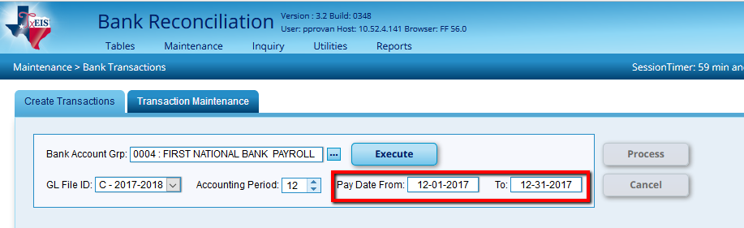
Only enter Pay Date’s if this Bank Account includes Payroll.

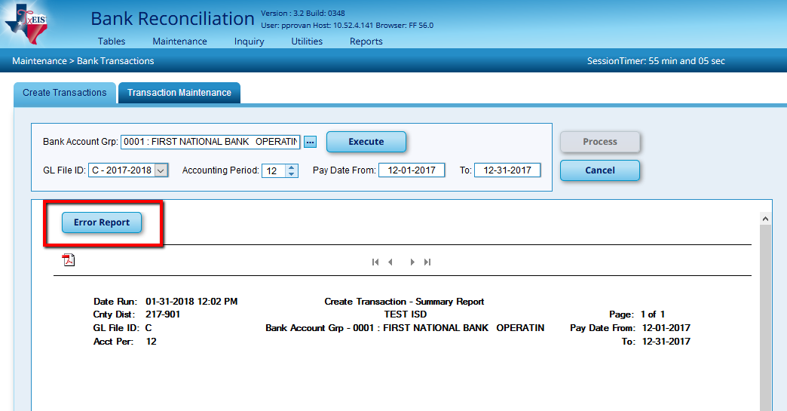
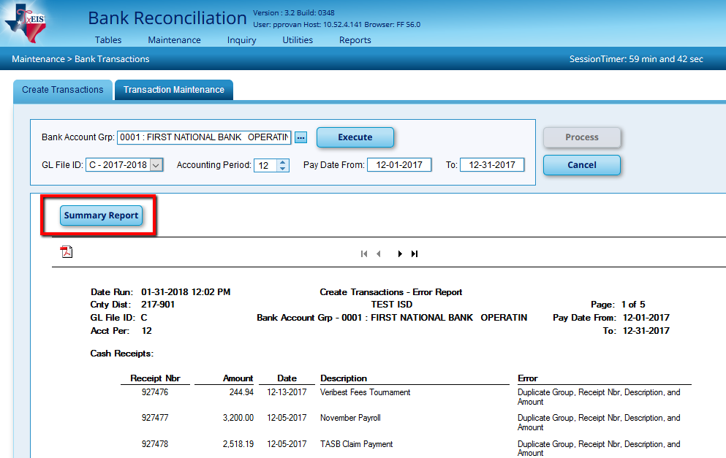
If there are errors, an error report is displayed. If no errors are encountered, the Error Report and Summary Report buttons are not displayed.
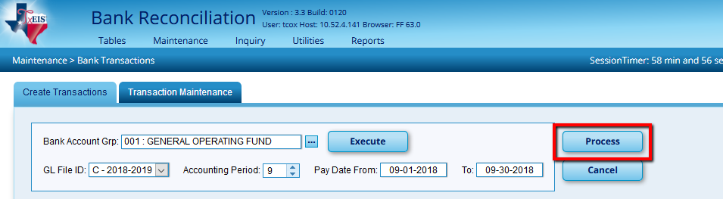

_______4. Transaction Maintenance
Bank Reconciliation > Maintenance > Bank Transactions >
Transaction Maintenance
Transaction Maintenance will allow you to create, edit, and delete unreconciled data from the bank reconciliation transactions table.
- Select a group code
- The associated transactions (Cash Receipts, Checks, and Journal Vouchers) are displayed in sections. When you click on one, whether it’s Cash Receipts, Checks or Journal Vouchers, it will expand the section and you are able to view each item. As shown below the Cash Receipts has been clicked on and thus been expanded.
- The group codes are populated from the Tables > Bank Account Fund Groups > Bank Account Group tab.
- Save changes.
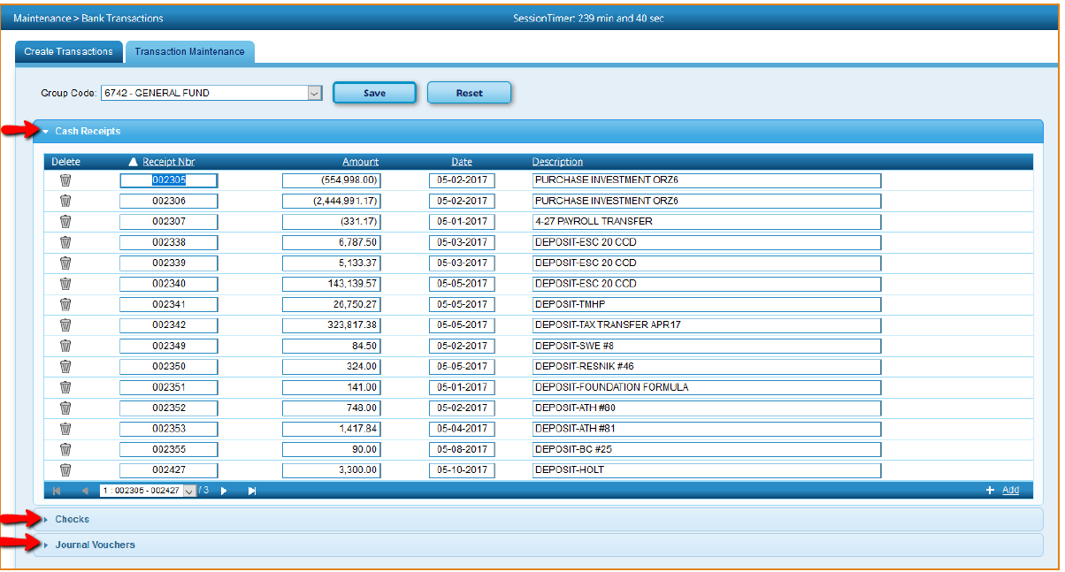
_______4. Bank Reconciliation
Bank Reconciliation > Maintenance > Bank Reconciliation
To reconcile a unreconciled bank transactions from the bank reconciliation transaction table. The transactions associated with the selected bank account group are displayed under the respective drop-down sections (Cash Receipts, Checks, Journal Vouchers). Select the transactions to be reconciled.
- To Create a New Bank Account Reconciliation
  - Enter a Reconciliation Title. We recommend MMYYY – Bank Account Group. This will make it easier to verify previous Reconciled Statements.
  - Use the Ellipses button to choose your Bank Account Group.
  - Verify the GL File ID
  - Enter the Accounting Period
  - Add

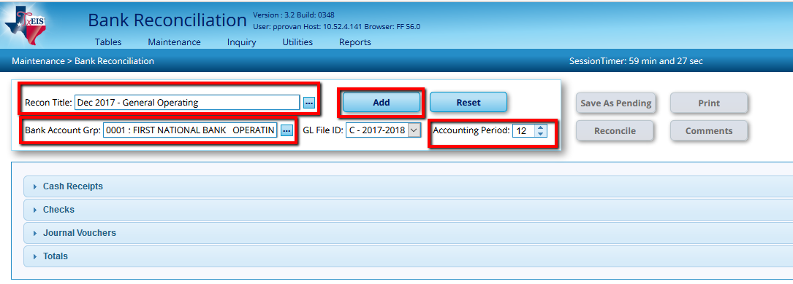

- To Pull and existing Bank Account Reconciliation
  - Type a bank reconciliation title or press the SPACEBAR to select from a list of unreconciled records.

  - You can also click on the Ellipses button to see both Reconciled and Pending Records.

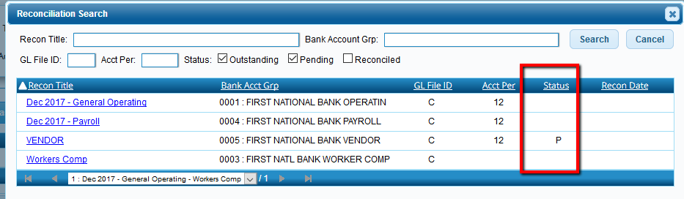

- The transactions associated with the selected bank account group are displayed under the respective drop-down sections (Cash Receipts, Checks, Journal Vouchers).
- Transactions can be selected one-by-one, or by using the Select All/Unselect All.

Note: Only one pending reconciliation is allowed per bank account at a time.

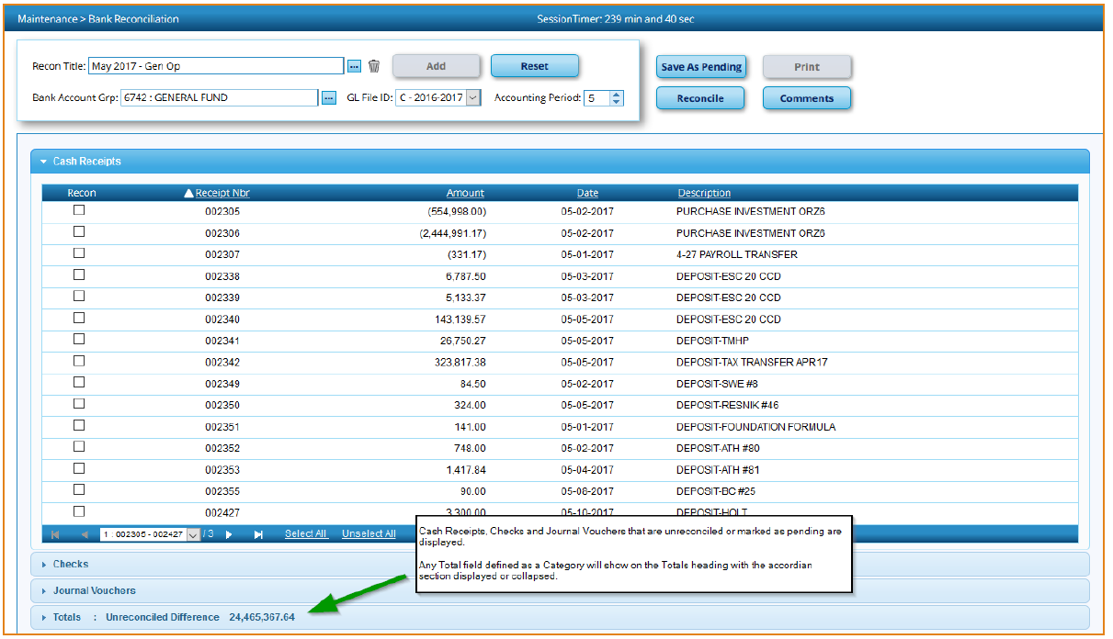

_______5. Compare the bank statement to the receipts on the Cash Receipts Journal. Check off deposits that have cleared on the Cash Receipts journal also the Cash Receipts on the Bank Rec.
  - On your current bank rec on the bank side, all deposits that cleared will be in the Cleared Deposits amount and will be checked on the Cash Receipts Journal that did clear the bank
  - On the system/book side, all Deposits that did not clear the bank but were on your Cash Receipts Journal will show on the Outstanding Deposits on the Bank Rec.
  - Checks or Deposits that cleared the bank for a different amount need to be corrected on the books or carried as a misc. adjustment due at bank.

_______6. Compare the bank statement list of checks on the Check Register. Check off checks that have cleared on the Check Register also the Checks on the Bank Rec.
- On your current bank rec on the bank side, all checks that cleared will be in the Cleared Checks amount and will be checked on the Check Register showing that they did clear the bank.
- On the system book side, all Checks that did not clear the bank but were on your Check Register will show on the Outstanding checks on the Bank Rec.
- Checks that cleared the bank for a different amount need to be corrected on the books.

_______7. Manually Enter
  - Previous Balance – Enter the previous balance from the bank statement.
  - Statement Balance Bank – Ending balance from Current Bank Statement
  - Statement Balance System - Ending balance from Current Bank Statement that you entered under the Statement Balance Bank.
  - Miscellaneous Adjustment – Use this field for any miscellaneous adjustment.

_______8. Look at the ‘Statement Cash Balance’ for the bank side and compare to the ‘Bank Statement Balance – Miscellaneous Adjustment’ on the book side. If they are equal, you balance and are done. If they are not equal, find the “difference”. (see separate document “Finding Differences”)

